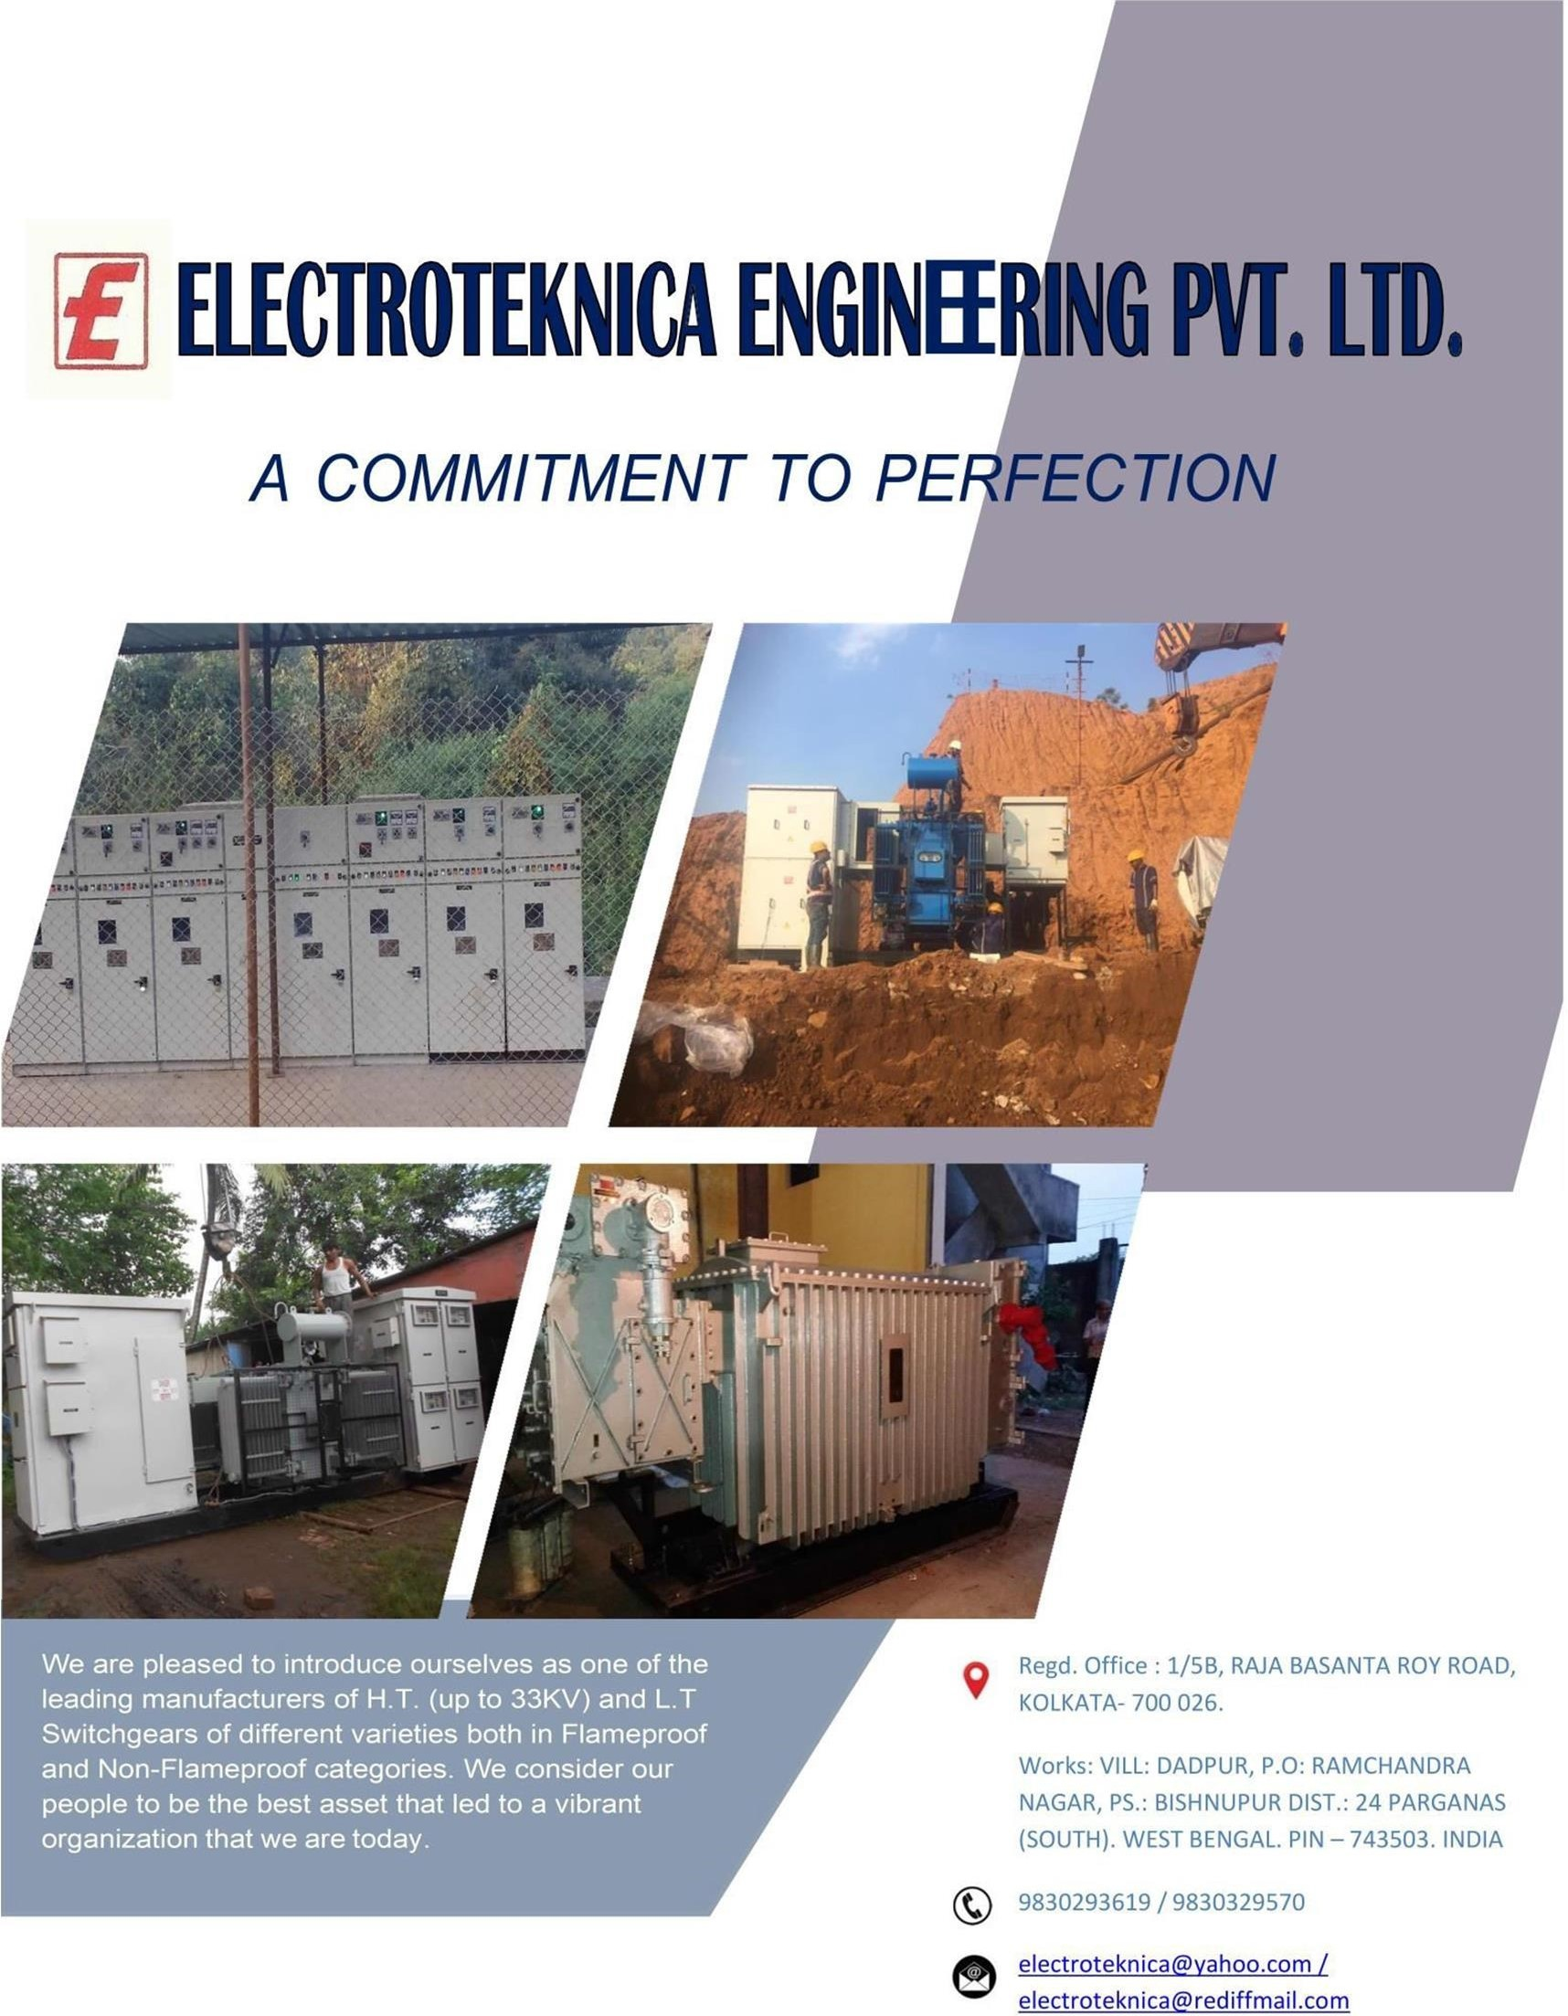

ELECTROTEKNICA ENGINEERING PVT. LTD.
A COMMITMENT TO PERFECTION

Electroteknica Engineering Pvt. Ltd. Was incorporated in 2003, with the purpose of offering various electrical equipments suitable for underground and surface mining applications. We are pleased to introduce ourselves as one of the leading manufacturers of H.T. (up to 33KV) and L.T. Switch Gears of different varieties both in Flameproof and Non-Flameproof categories.

We are registered with National Small Industries Corporation Ltd, a Government accredited authority and are registered under MSMED Act as MICRO Enterprise. Most of the products mentioned in the range of products are type tested at Central
Power Research Institute & Central Institute Mining & Fuel Research Institute, both Govt.
authorized testing laboratories. The Flameproof products are also approved by directorate
General of Mines Safety & Bureau of Indian Standards for use in underground Mines suitable for Gas Group-1 Application & BIS marked.

We consider our people to be the best asset that led to a vibrant organization that we are today.



Today, Electroteknica Engineering Pvt. Ltd. Delivers products & services to global Companies like Coal India Ltd and all its subsidiaries, Tata Steel Limited, MOIL limited, Uranium Corporation of India Ltd., Hindustan Copper Ltd., HINDALCO, Taiyuan Heavy Industry Co. Ltd. (china), China Coal No. 3 Mining (India) Pvt. Ltd., The Singareni Collieries Co. Ltd. And Indian companies like Voltas Ltd., JMS Mining Ltd., SMS Limited, Kirloskar Brothers Ltd. to name a few.
We strive for Total Customer Satisfaction through transparent business practices and our aim is to have all people, who interact with us, regard us as a good company to work for, to buy from and to sell to.




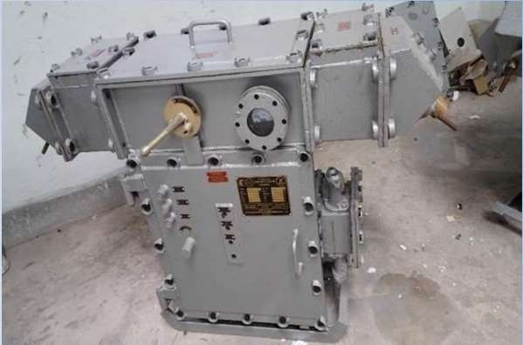

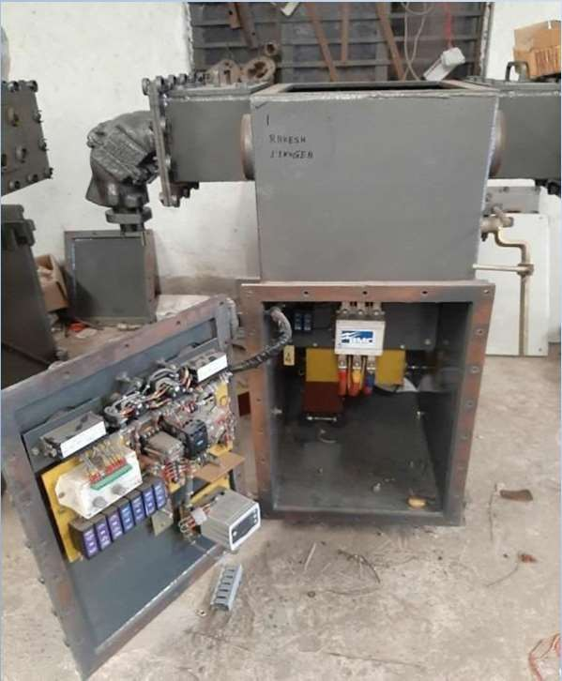
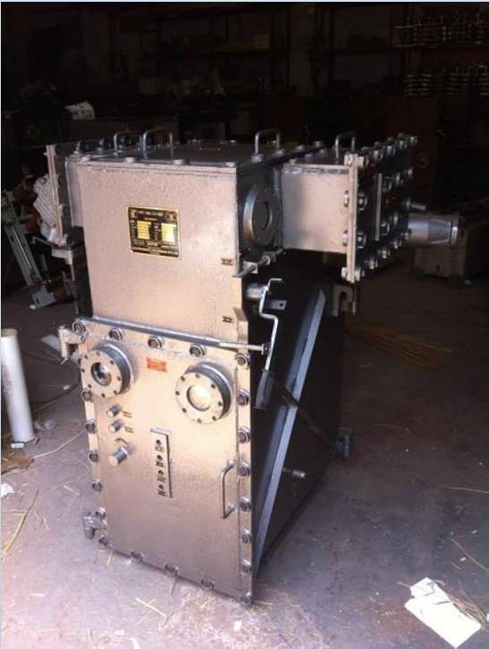
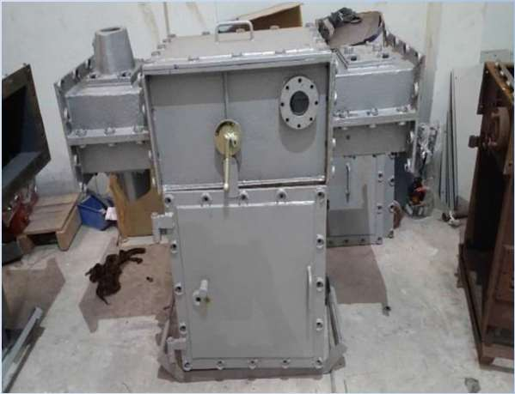
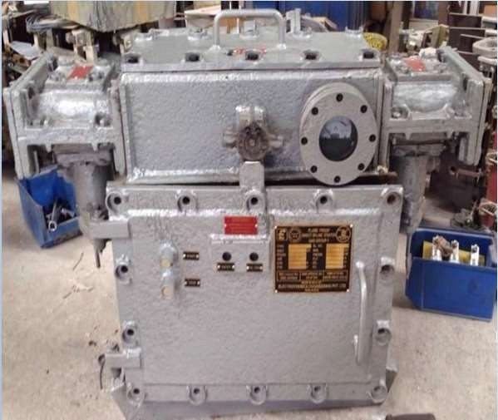
ELECTROTEKNICA ENGINEERING PVT. LTD.
A COMMITMENT TO PERFECTION

FLAMEPROOF (MOTOR CONTROL SWITCH UPTO 550V)
- DOL STARTERS UPTO 250HP
- STAR DELTA STARTERS UPTO 250HP
- DUAL DRIVE STARTERS UPTO 250HP
- REVERSING STARTERS UPTO 250HP
- AUTOMATIC WINCH CONTROL PANEL
- GATE END BOX UPTO 300A
- AIR CIRCUIT BREAKER UPTO 400A
- DRILL CONTROL PANEL (1.5KVA/2.5KVA)
- LIGHTING TR UPTO 5KVA

FLAMEPROOF UPTO 1100/6600 VOLTS

  - GATE END BOX UPTO 400A
  - VACUUM CIRCUIT BREAKER PANEL
  - DOL STARTERS





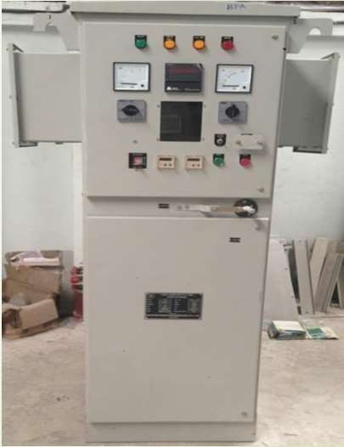
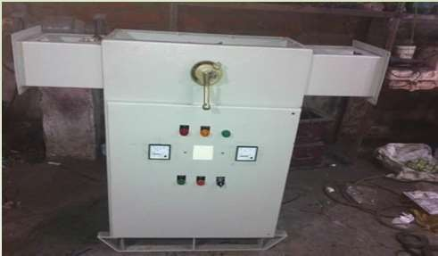
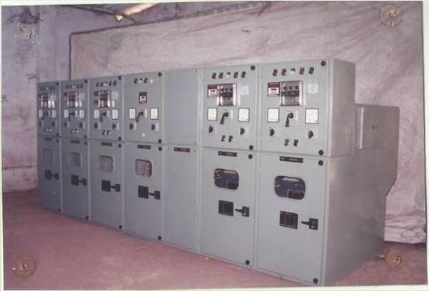
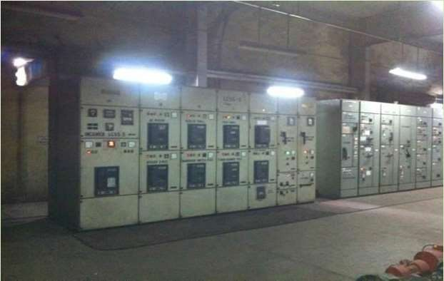

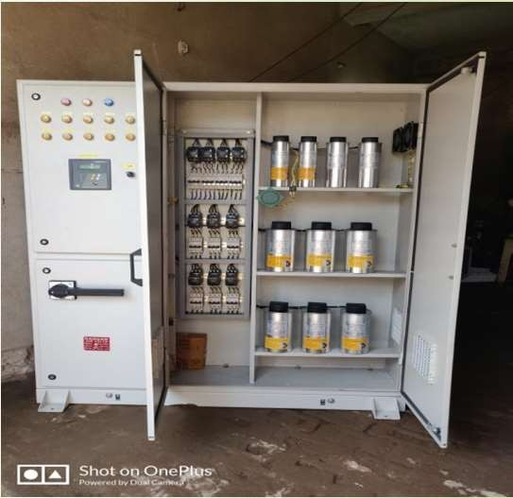
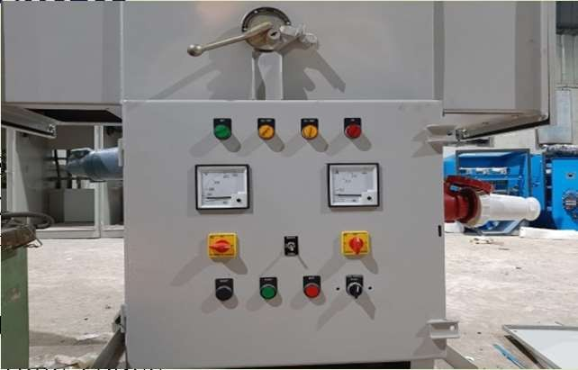
ELECTROTEKNICA ENGINEERING PVT. LTD.
A COMMITMENT TO PERFECTION

NON-FLAMEPROOF (MOTOR

CONTROL SWITCH UPTO 550V)
- DOL STARTERS
- STAR DELTA STARTERS
- DUAL DRIVE STARTERS
- REVERSING STARTERS
- VFD PANEL
- AUTO TRANSFORMER STARTER
- STATOR ROTOR CONTROL PANEL

NON-FLAMEPROOF UPTO 1100/ 6600
VOLTS

- DOL STARTERS
- STAR-DELTA STARTERS
- STATOR ROTOR CONTROL PANEL
- AUTO TRANSFORMER STARTERS
- MINING TYPE VACUUM CIRCUIT BREAKER PANEL (INDOOR/ OUTDOOR TYPE)
- MINING TYPE H.T SWITCH BOARD PANEL (INDOOR/OUTDOOR TYPE)
- MINING TYPE ISOLATOR PANEL
- AIR CIRCUIT BREAKER PANEL UPTO 2000A
- 6.6 400A VACUUM CONTACTOR





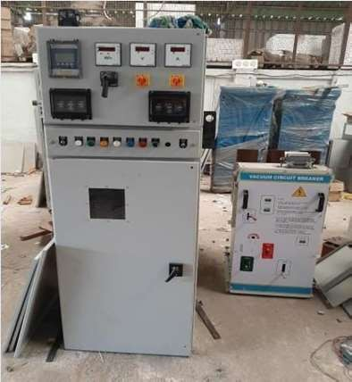
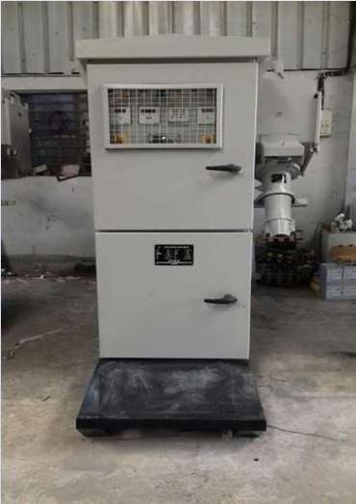
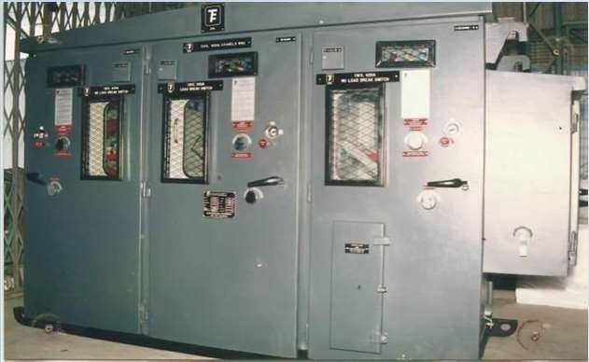
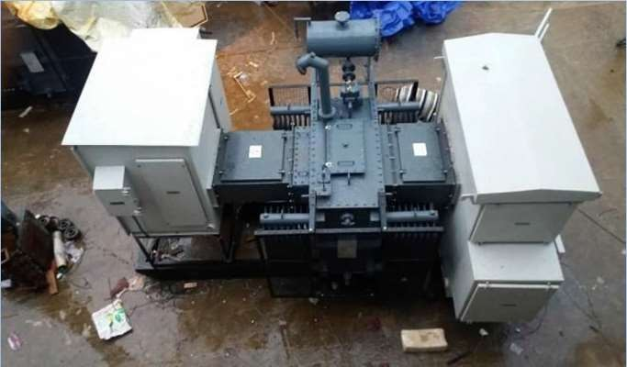
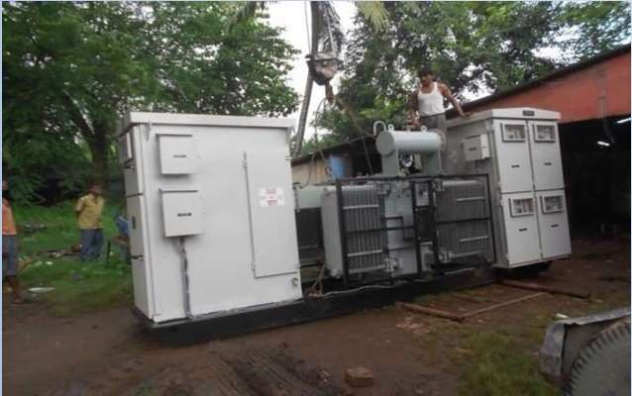
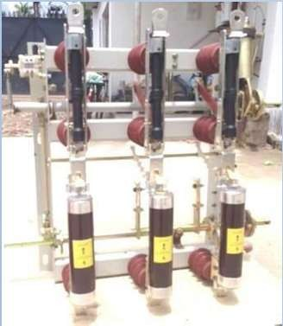
ELECTROTEKNICA ENGINEERING PVT. LTD.
A COMMITMENT TO PERFECTION

UPTO 11000/ 33000 VOLTS RANGE
  - VACUUM CIRCUIT BREAKER PANEL INDUSTRIAL TYPE 11KV
/33KV 1250A (INDOOR/OUTDOOR KIOSK TYPE)

    - FIELD SWITCH WITH PLUG & SOCKET/ KIOSK TYPE

    - LOAD BREAK SWITCH FUSE PANEL (ON LOAD ISOLATOR/ RING MAIN UNIT)

    - UNITIZED SUB STATION UPTO 1MVA





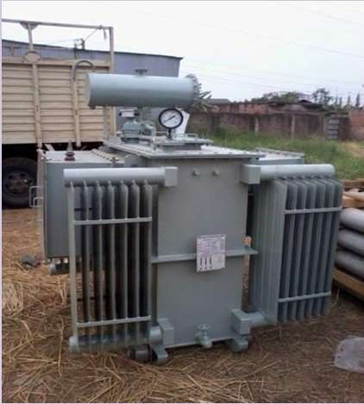
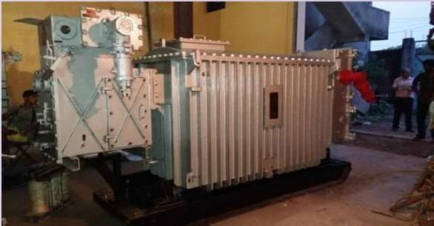
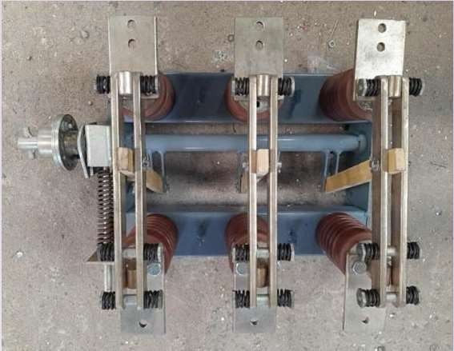
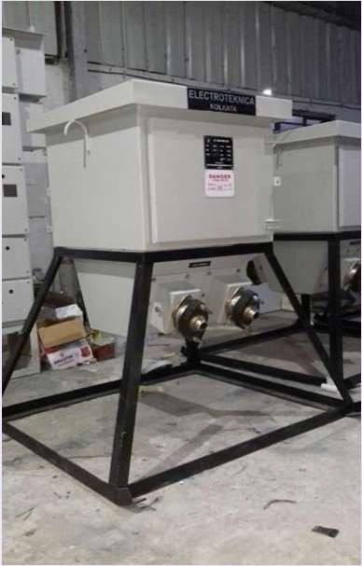
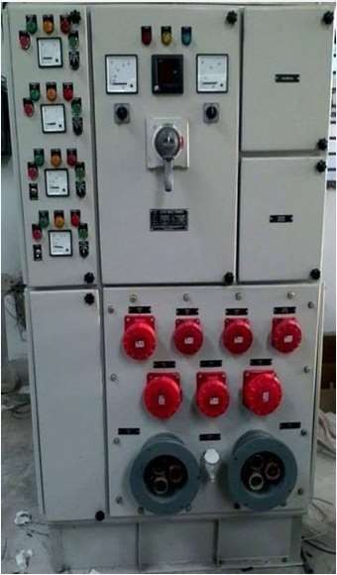
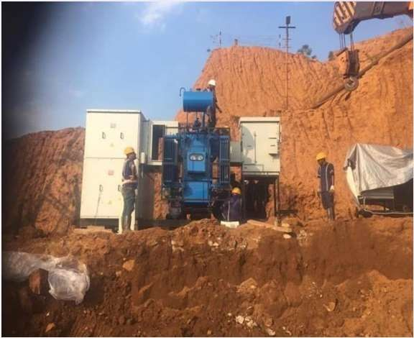
ELECTROTEKNICA ENGINEERING PVT. LTD.
A COMMITMENT TO PERFECTION

TRANSFORMERS
      - 11/0.433KV OIL COOLED POWER & DISTRIBUTION TRANSFORMER UPTO 1250KVA

      - 11/0.433KV AIR COOLED POWER & DISTRIBUTION TRANSFORMER UPTO 1250KVA

- LIGHTNING TRANSFORMER

CUSTOMIZED EQUIPMENTS
- FLAMEPROOF TRANSWITCH UNIT UPTO 3300V/1100V & 550V UPTO 1200KVA WITH A PROVISION OF IN BUILT LIGHTNING TRANSFORMER

- OFF LOAD ISOLATOR UPTO 11KV 5000A

- N FL P LO A D C E N T R E

- JU N C T IO N B O X





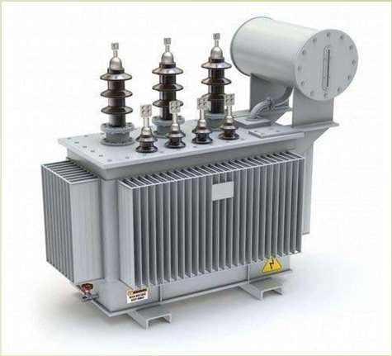
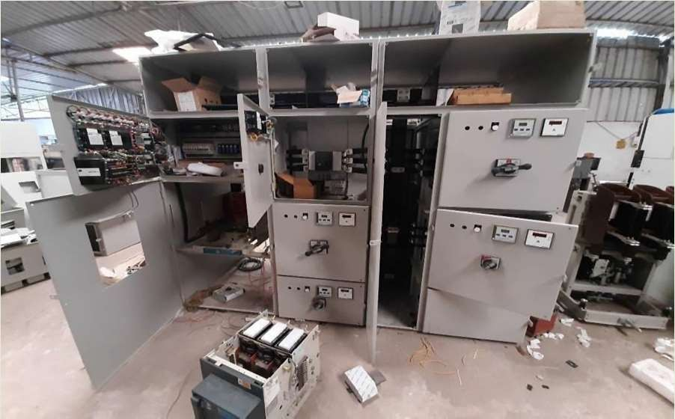
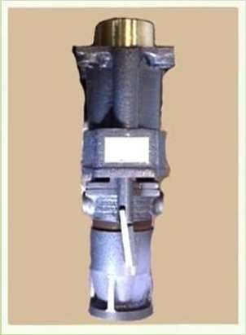
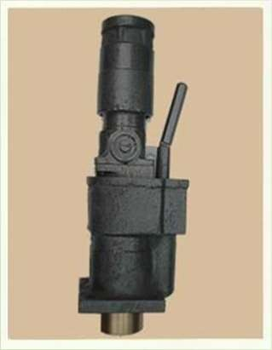
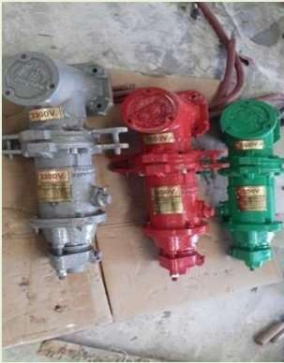
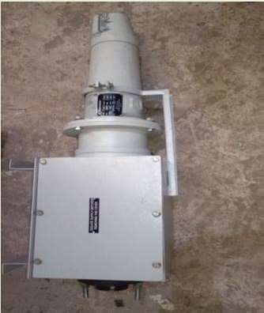
ELECTROTEKNICA ENGINEERING PVT. LTD.
A COMMITMENT TO PERFECTION

LT CONTROL GEARS
  - AUTOMATIC VOLTAGE REGULATOR

  - LT SWITCHBOARD PANEL

  - 11KV/ 33KV CONTROL and RELAY PANEL

  - LT CAPACITOR PANEL

  - LT DISTRIBUTION

  - HEATER CONTROL PANEL

C O U P L E R S / P L U G & S O C K E T

- R EST R A IN ED T YP E P LU G & SO C K ET U PT O 1 .1 K V U PT O 40 0 A
- RESTRAINED TYPE PLUG & SOC KET UPTO 1 .1 KV UPTO 200 A
- R EST R A I N E D T Y P E PLU G & SO C K ET U PT O 55 0 V U PT O 50 A
- ANGLE A DA PTOR & CA BLE COUPLER UPTO 11 KV 630 A



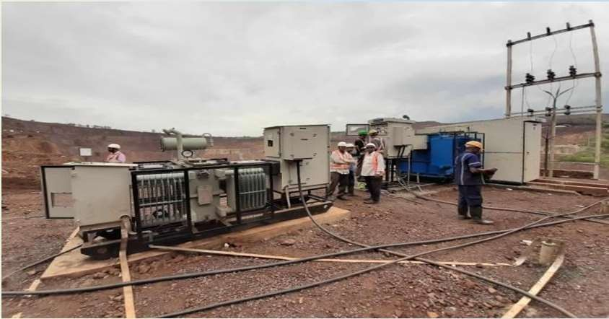
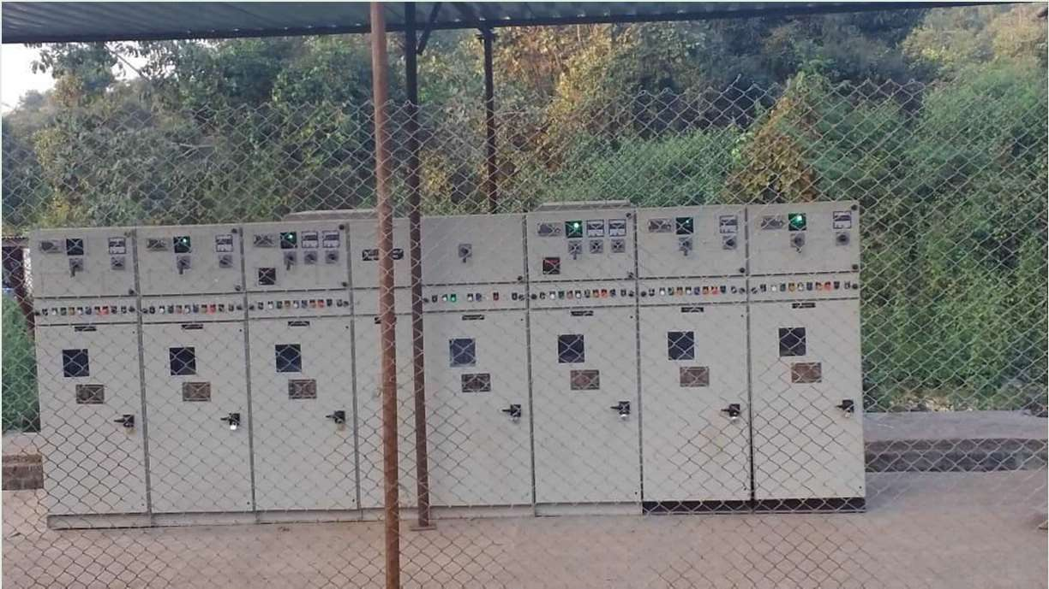
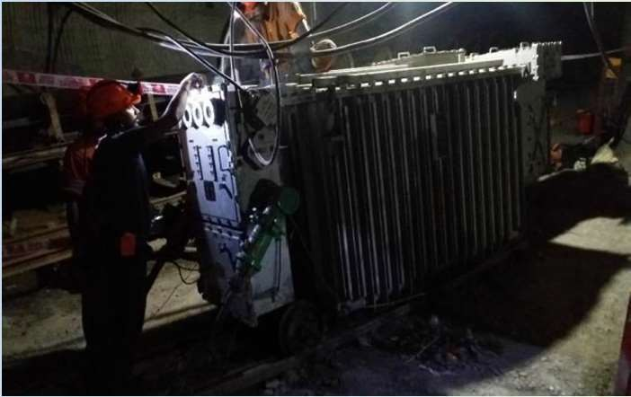
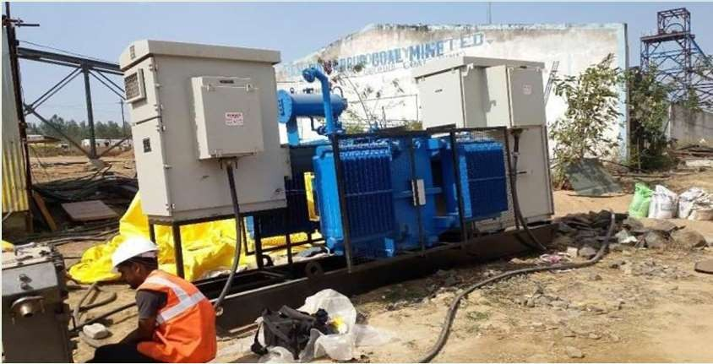
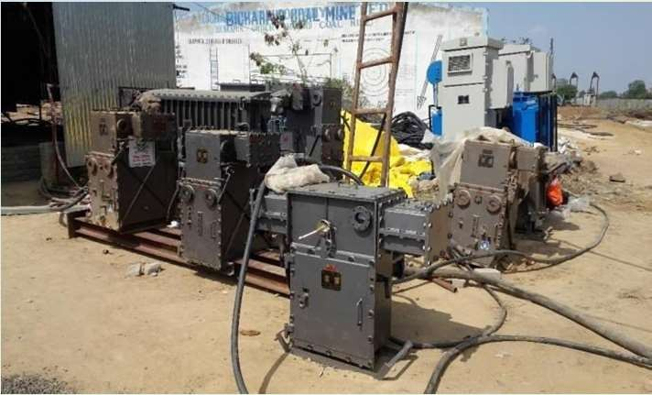
ELECTROTEKNICA ENGINEERING PVT. LTD.
A COMMITMENT TO PERFECTION

HINDUSTAN COOPER LIMITED, MALANJKHAND

BALASORE ALLOYS LTD. EASTERN COALFIELDS, KUMAR DIHI B

BICHARPUR COAL MINES, SHAHDOL

(UNDERGROUND AND SURFACE MINING EQUIPMENT)

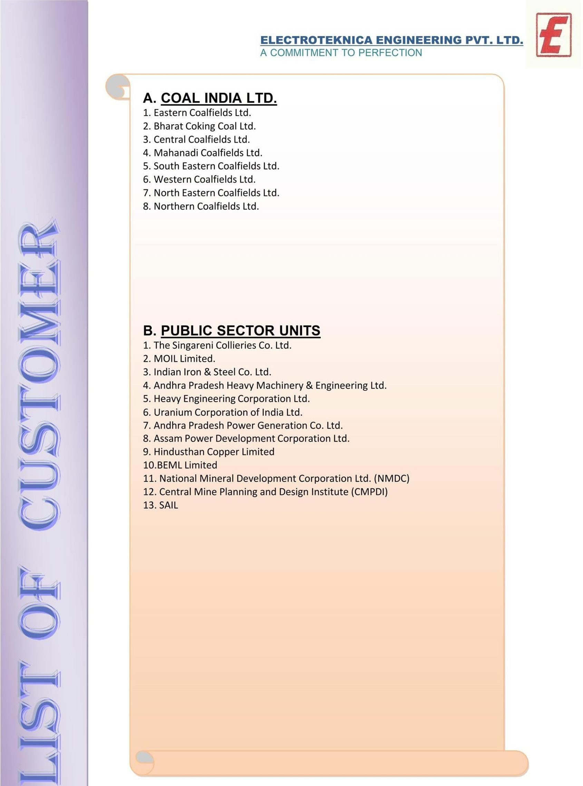

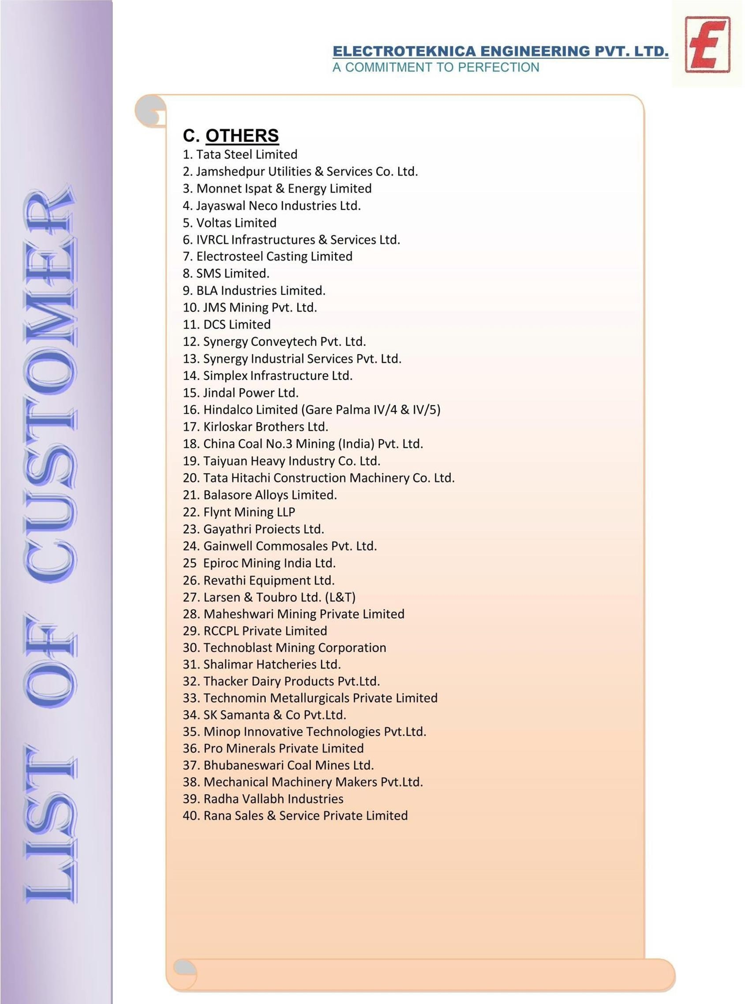



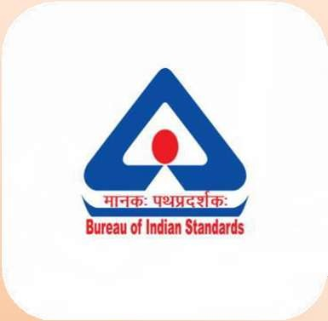






ELECTROTEKNICA ENGINEERING PVT. LTD.
A COMMITMENT TO PERFECTION

